Machine Learning Fundamentals
Types of Machine Learning Models:
- Classification: Identification of Dogs, Cats, if an email is spam or not, etc.
- Regression: Regression Models are used to predict continuous values.
- Clustering: If you want to group a large amount of data, and so are supposed to find an underlying pattern of sorts.
- Dimensionality Reduction: Insignificant dependencies or values of the data are removed in order to make it more workable.
Input to the ML algorithm is referred to as X variables i.e. Feature Vector.
The output that the ML algorithm gives is known as Y variables i.e. Labels.
The Outputs of the ML algorithm is not always correct, hence, a loss function is used to generate losses and the same is passed as an input to the ML Algorithm which then helps improve the ML Model.
The choice of the feature vector is quiet important as any mistake in that would lead to a wrong output/label.
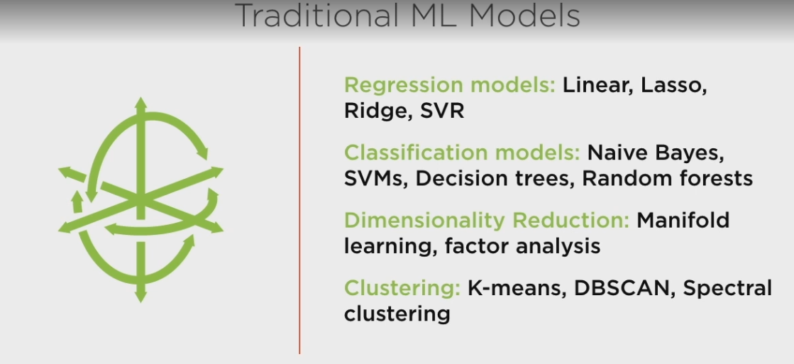

Model Parameters are the variables in any model that learn from Data.
In Traditional Based Models, we must decide what features to pay attention to and what not to.
For larger data and complex data we use Representation ML Models.
Representation Models:
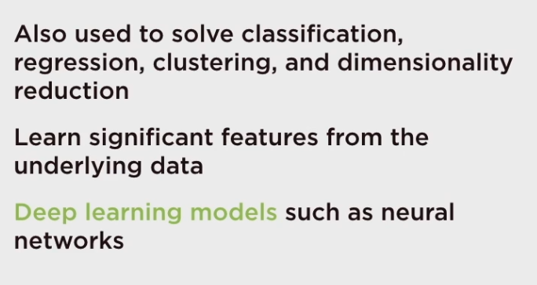
Scikit Learn supports Traditional Models.

Supervised V/S Unsupervised Learning:
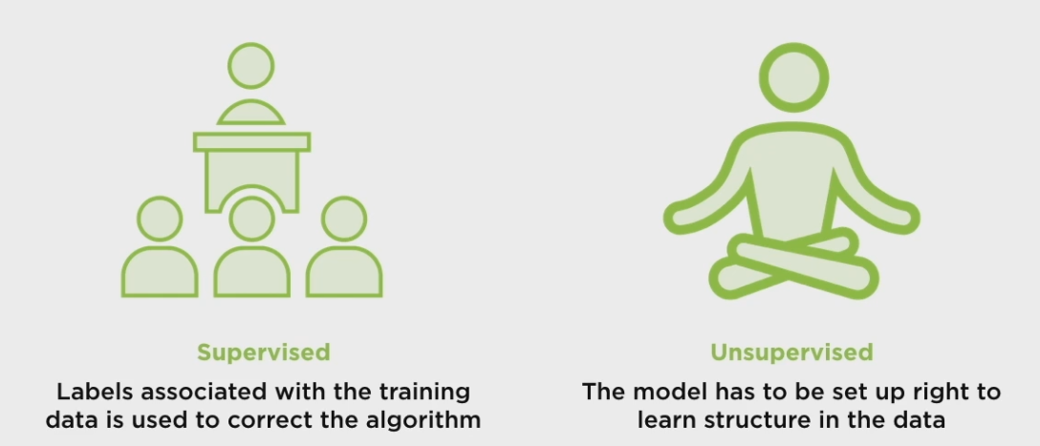
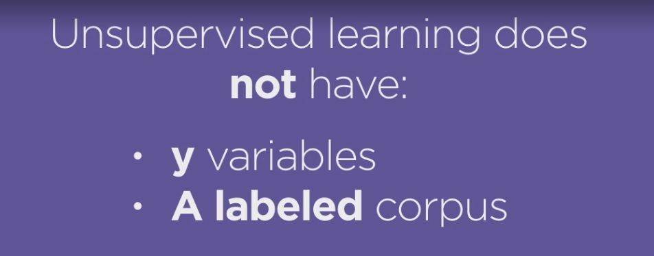
Supervised Learning: Classifier and Regression
Unsupervised Learning: Clustering, Dimensional Reduction.

Machine Learning Workflow:
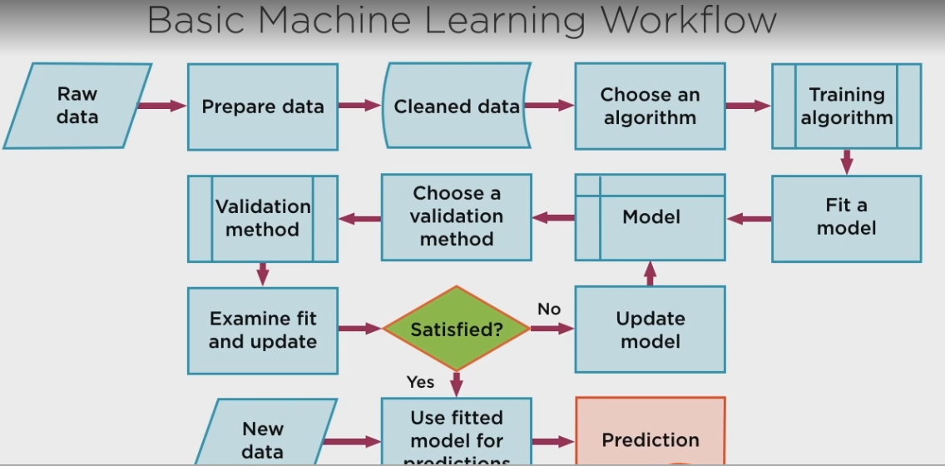
In Order To Choose the right classifier check the link below:
https://scikit-learn.org/stable/tutorial/machine_learning_map/index.html
Classification:
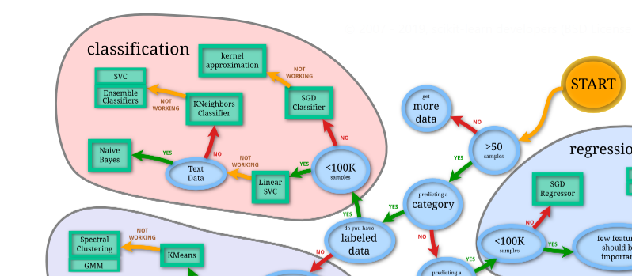

Clustering:
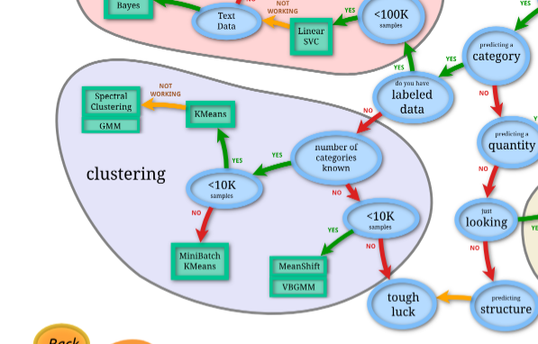

Dimension Reduction and Regression:
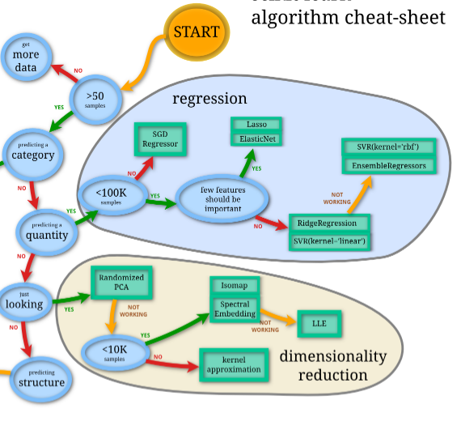

Linear Regression Workflow:
Step 1: Normalize Your Data:
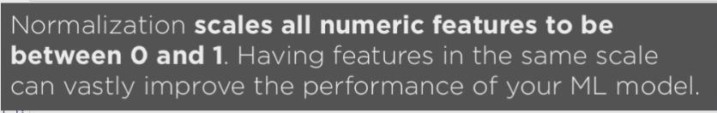
Score:
Coefficient:
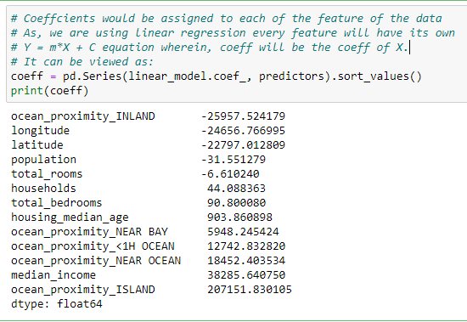
- Negative Values indicate it those features reduce the mean price
- Positive Values indicates those features increases the mean price

2. Prediction:
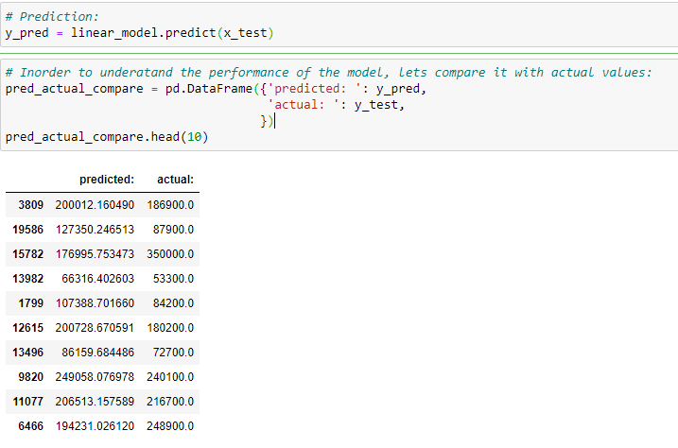
Testing Predictions:
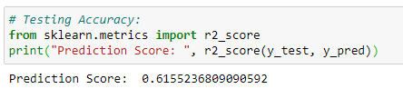
As the Prediction Score is somewhat similar to Testing Score, the model created is thus decent.

Visualize this data in various ways in order to understand how well the model performs.
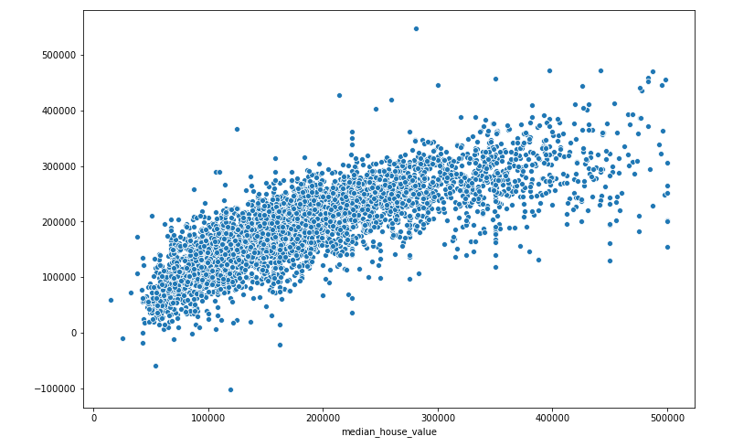
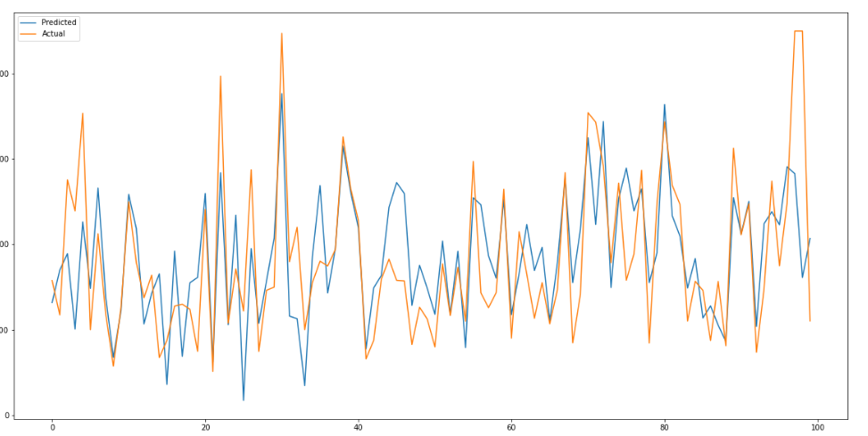

Logistic Regression
This is used for clustering algorithms.

